**Hosting a Static Website in S3**

After logging in AWS Management console select S3 from Storage Tab.

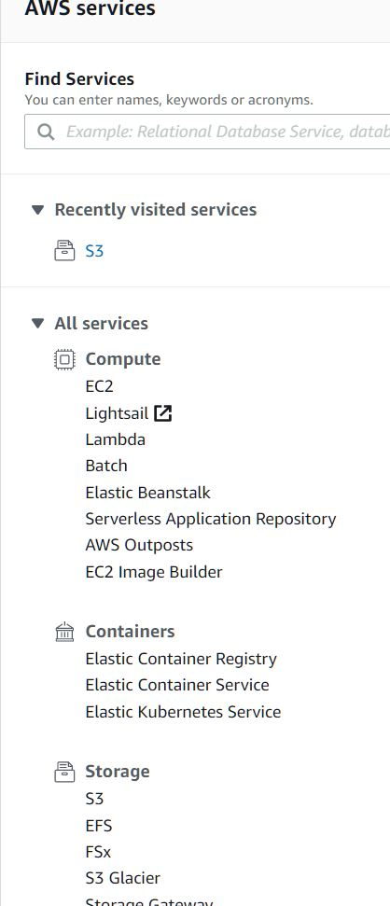

Then Create a new Bucket and Name it and select public access.

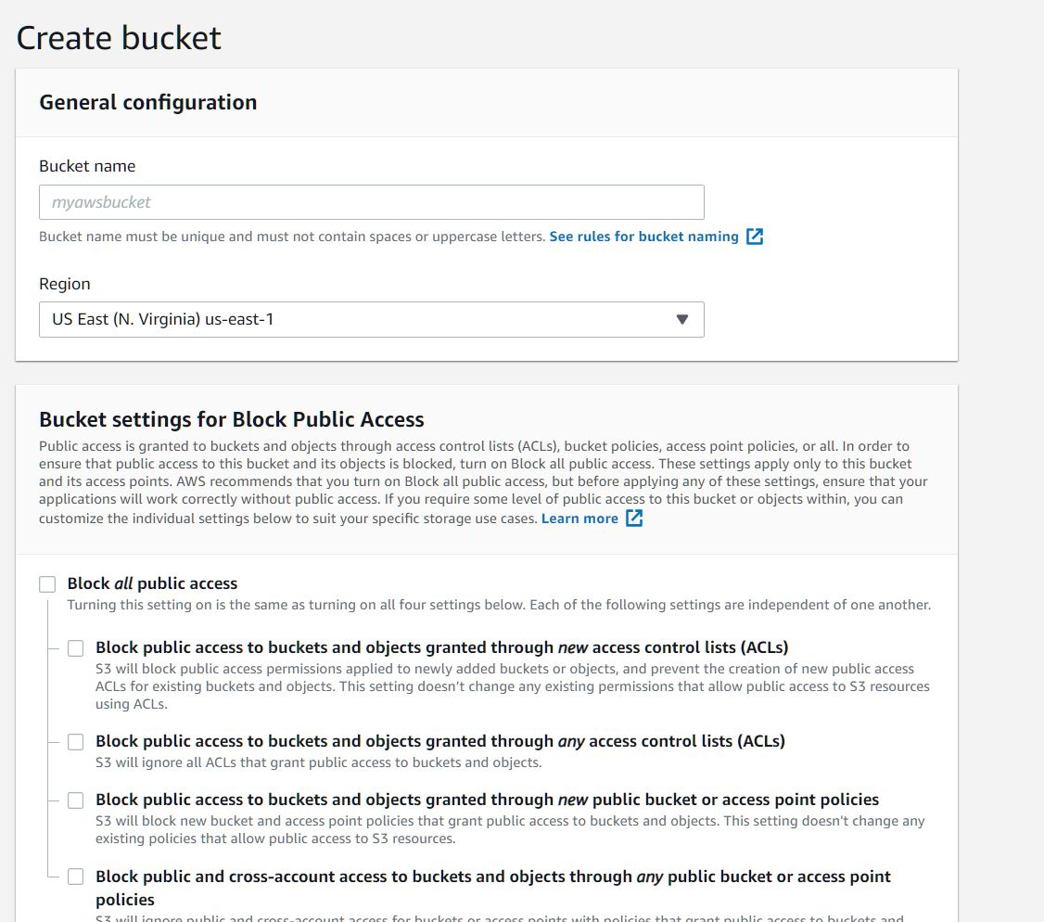

Upload index.html and error.html

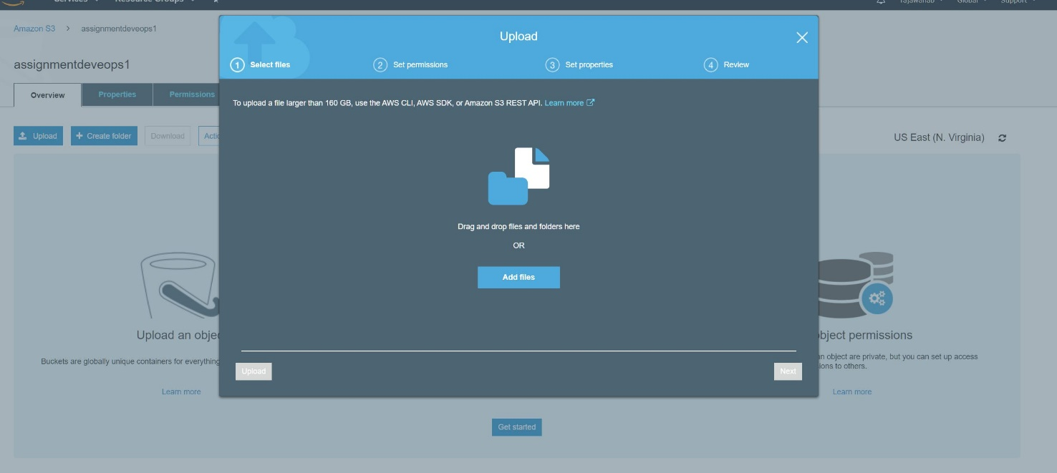

Select standard storage class

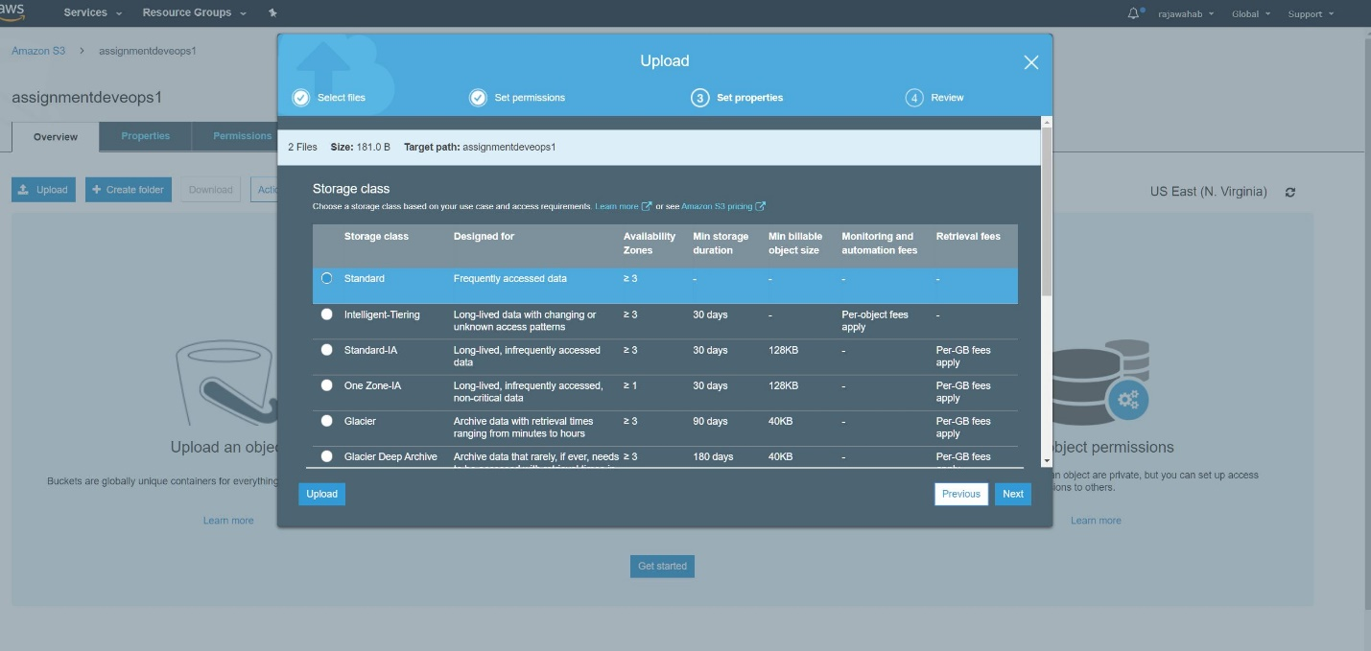

Make both the files available to public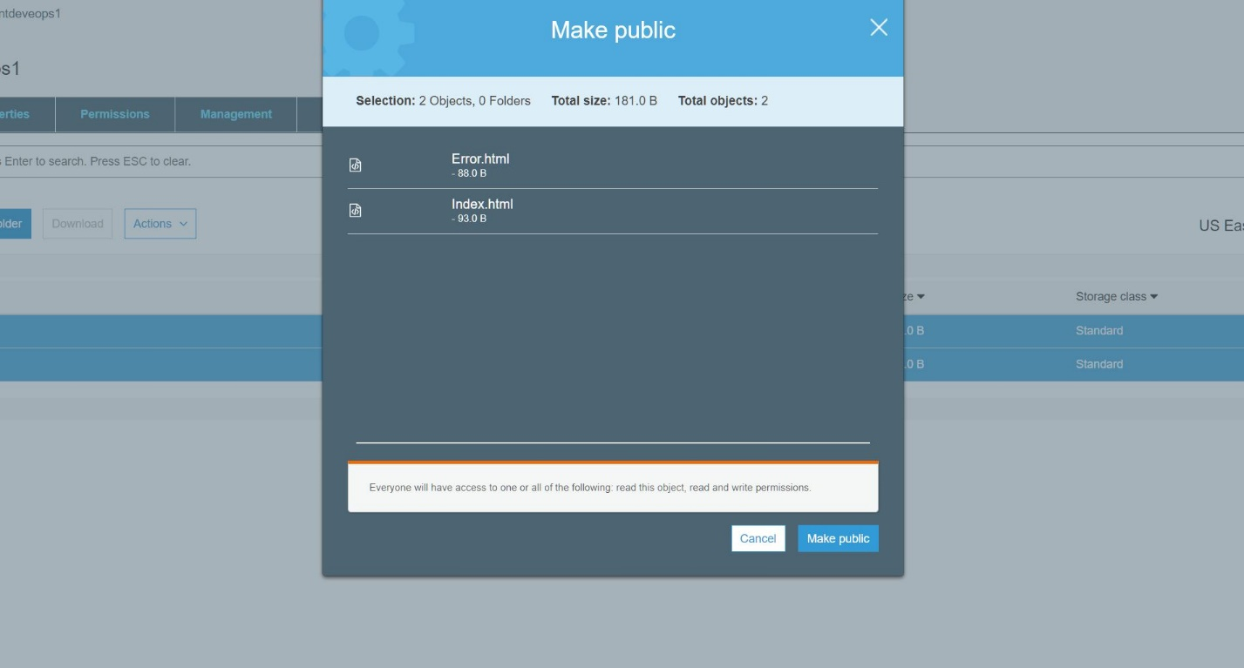

Go to properties of Bucket and Select static website hosting

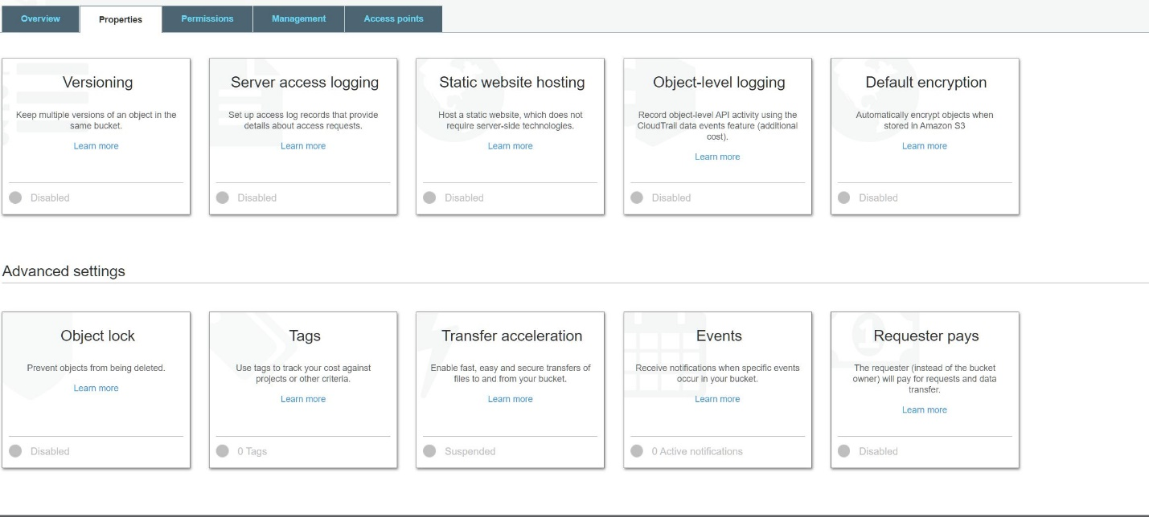

Select your index.html and error.html files and save the option

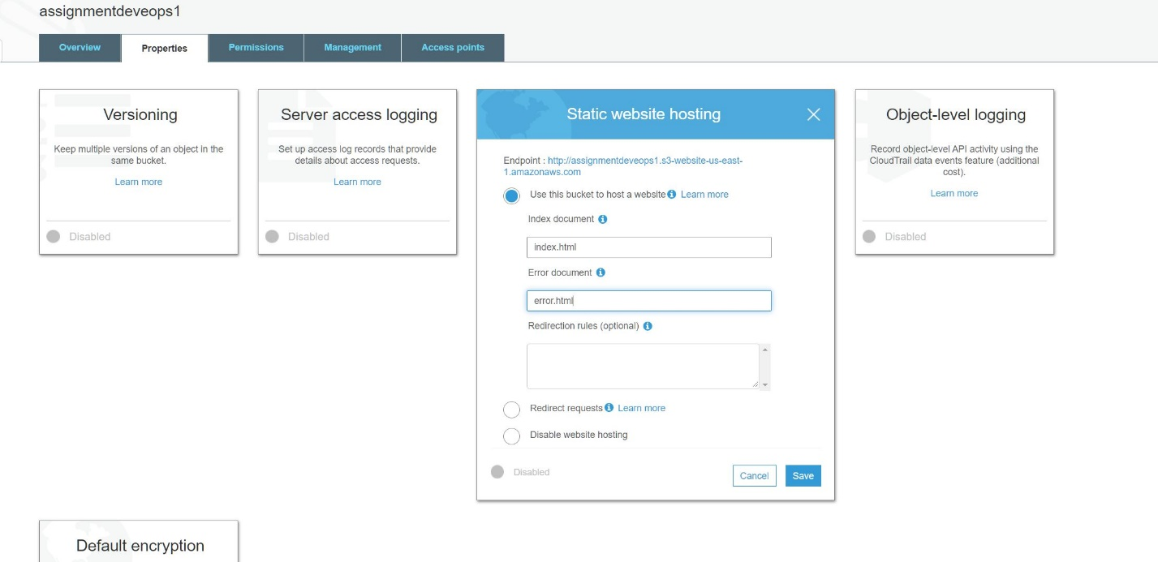

The web address for my static website

http://assignmentdeveops1.s3-website-us-east-1.amazonaws.com